Assignment 1: Design Considerations for Deploying Global ERP, CRP, and Supplier Solutions

As architects, you are tasked with designing a well-architected framework for deploying ERP, CRP, and supplier solutions across the globe. Your goal is to create a scalable and reliable architecture that can support the needs of users in different regions while also ensuring compliance with data regulatory requirements, optimizing costs, and maximizing service availability. To achieve this goal, consider the following design considerations:

1. Proximity to end-users: Identify the regions where the solutions will be deployed and analyze the proximity of the data centers to the end-users. Evaluate the latency and network performance to determine the optimal location for the data center. Consider using content delivery networks (CDNs) or edge computing to reduce latency and improve user experience.
2. Data regulatory requirements: Identify the data regulatory requirements for each region and ensure that the architecture is compliant with all relevant regulations. This may include data residency requirements, data privacy regulations, and other data protection laws.
3. Expansion strategy: Consider the potential for expansion in each region and design the architecture to support future growth. Evaluate the scalability and elasticity of the architecture to ensure that it can accommodate additional users and workloads.
4. Cost: Evaluate the cost of deploying and operating the solutions in each region. Consider using cloud-based solutions or hybrid architectures to optimize costs while ensuring high performance and availability.
5. Service availability: Design the architecture to ensure high availability and resiliency in case of failures or disasters. Consider using disaster recovery strategies such as failover to different regions, replication of data across regions, and automatic failover of services.

Deliverables:

* A well-architected framework design that addresses the above design considerations
* A cost-benefit analysis that evaluates the costs and benefits of the proposed architecture
* A deployment plan that outlines the steps required to implement the architecture in each region

Note: Your design should take into account the unique requirements and constraints of each region and should be flexible enough to adapt to future changes in requirements or expansion plans.

## Evaluate Global Rollout

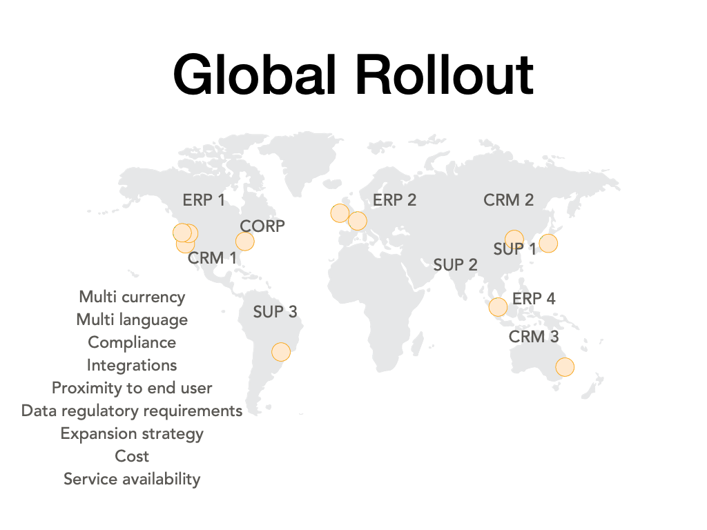

# Solution:

1. Proximity to end-users: To ensure optimal performance and user experience, it's important to consider the proximity of the data center to the end-users. This can be done by analyzing the regions where the solutions will be deployed and evaluating the latency and network performance to determine the optimal location for the data center. You can use tools such as traceroute or latency measurement tools to gather data on network performance.

Once you've identified the optimal location for the data center, you can consider using content delivery networks (CDNs) or edge computing to reduce latency and improve user experience. CDNs can distribute content to edge servers located closer to the end-users, reducing the latency and improving the speed of content delivery. Edge computing can process data closer to the end-users, reducing the need to send data back to the data center for processing.

1. Data regulatory requirements: Different regions have different data regulatory requirements that need to be considered when designing a well-architected framework for deploying ERP, CRP, and supplier solutions. This includes data residency requirements, data privacy regulations, and other data protection laws.

To ensure compliance with these regulations, it's important to identify the specific requirements for each region and design the architecture accordingly. **This may include using encryption, implementing access controls, or using specific data storage solutions that meet regulatory requirements.**

* Expansion strategy: When designing the architecture for global deployment of ERP, CRP, and supplier solutions, it's important to consider the potential for expansion in each region. This includes evaluating the scalability and elasticity of the architecture to ensure that it can accommodate additional users and workloads.

To support future growth, you can consider using cloud-based solutions or hybrid architectures that can be easily scaled up or down as needed. This can include using cloud-based services such as AWS or Azure, or using hybrid architectures that combine cloud-based and on-premise solutions.

* Cost: To optimize costs while ensuring high performance and availability, it's important to evaluate the cost of deploying and operating the solutions in each region. This includes considering the cost of hardware, software, and personnel required to operate the solutions.

To optimize costs, you can consider using cloud-based solutions that offer a pay-per-use pricing model, allowing you to scale up or down as needed without incurring additional costs. You can also consider using cost optimization techniques such as resource tagging, resource rightsizing, and using reserved instances to reduce costs.

* Service availability: Designing the architecture to ensure high availability and resiliency in case of failures or disasters is critical for global deployment of ERP, CRP, and supplier solutions. This includes using disaster recovery strategies such as failover to different regions, replication of data across regions, and automatic failover of services.

To ensure high availability, you can consider using redundant hardware, load balancing, and automatic failover mechanisms. You can also consider using backup and recovery strategies such as snapshot backups and disaster recovery plans that ensure data and services can be restored quickly in case of a disaster.

Deliverables:

To complete the assignment, you should deliver the following:

* A well-architected framework design that addresses the above design considerations
* A cost-benefit analysis that evaluates the costs and benefits of the proposed architecture
* A deployment plan that outlines the steps required to implement the architecture in each region

The well-architected framework design should take into account the unique requirements and constraints of each region and should be flexible enough to adapt to future changes in requirements or expansion plans. It should also ensure compliance with data regulatory requirements, optimize costs, and ensure high availability and resiliency in case of failures

## Cost-benefit analysis

A cost-benefit analysis is a key component of any well-architected framework design. It helps evaluate the costs and benefits of the proposed architecture, providing insights into the financial implications of the design.

To perform a cost-benefit analysis for deploying global ERP, CRP, and supplier solutions using a well-architected framework, you should consider the following:

1. Cost of hardware and software: The cost of hardware and software required for the architecture is a key consideration. This includes the cost of servers, storage devices, networking equipment, and software licenses. You should evaluate the cost of each component and identify opportunities to optimize costs by using cloud-based solutions or open-source software.
2. Cost of personnel: The cost of personnel required to operate and maintain the architecture is another important consideration. This includes the cost of hiring and training IT staff, as well as the ongoing salaries and benefits of the staff. You should evaluate the cost of personnel for each region and identify opportunities to optimize costs by using managed services or outsourcing some of the operations.
3. Cost of data transfer and storage: The cost of data transfer and storage is another key consideration. This includes the cost of transferring data between regions, as well as the cost of storing data in each region. You should evaluate the cost of data transfer and storage for each region and identify opportunities to optimize costs by using compression techniques, data deduplication, or leveraging cloud-based storage solutions.
4. Cost of downtime: The cost of downtime is another important consideration, as it can have significant financial implications for the business. You should evaluate the cost of downtime for each region and identify opportunities to minimize downtime by using redundant hardware, automatic failover mechanisms, or other high-availability strategies.
5. Benefits of the architecture: Finally, you should evaluate the benefits of the proposed architecture. This includes the potential benefits in terms of improved performance, availability, and scalability, as well as the potential for cost savings through optimization and automation. You should quantify the benefits of the architecture and compare them to the costs identified above to determine the overall cost-benefit ratio of the proposed architecture.

Based on the results of the cost-benefit analysis, you can make informed decisions about the optimal architecture for global deployment of ERP, CRP, and supplier solutions. You can identify opportunities to optimize costs, improve performance and availability, and ensure compliance with data regulatory requirements, while also ensuring that the architecture is scalable and flexible enough to accommodate future expansion plans.

## Deployment plan:

A well-architected framework design for a cloud solution should always include a deployment plan that outlines the steps required to implement the architecture in each region. The deployment plan should be comprehensive and considerate of the unique requirements of each region, including differences in infrastructure, compliance regulations, and security requirements.

The following are some key steps to include in a deployment plan for a well-architected framework design:

1. Define the target regions: The first step in developing a deployment plan is to define the target regions where the architecture will be deployed. This may include regions where the business already operates or regions where it plans to expand in the future.
2. Identify the infrastructure requirements: Next, the deployment plan should identify the infrastructure requirements for each region, including the type of compute instances, storage, networking, and other resources that are needed to support the architecture. It is important to consider the differences in infrastructure between regions and identify any regional-specific requirements.
3. Evaluate the regulatory and compliance requirements: Each region may have different regulatory and compliance requirements that need to be met. It is important to evaluate these requirements and ensure that the architecture design and implementation meet these requirements. **This may include data protection laws, privacy regulations, or any other legal requirements that must be followed.**
4. Develop a security plan: A security plan should be developed to ensure that the architecture is secure and meets the specific security requirements of each region. This may include data encryption, access control, network security, and other measures to protect the system against cyber threats.
5. Define the deployment process: The deployment process should be defined in detail, outlining the steps required to deploy the architecture in each region. This may include creating and configuring the infrastructure, deploying software and applications, and testing the system to ensure that it is functioning as expected.
6. Implement the deployment plan: Once the deployment plan has been defined, it is time to begin implementing it in each region. This process should be carefully managed and monitored to ensure that each region is deployed successfully and meets all of the required criteria.

By including a comprehensive deployment plan in the well-architected framework design, businesses can ensure that the architecture is deployed efficiently and effectively in each region, meeting all necessary infrastructure, regulatory, and security requirements. This approach can help businesses avoid costly mistakes and ensure that the architecture is implemented correctly, enabling the organization to focus on delivering value to its customers.

## Data Regulatory Requirements

Data regulatory requirements can vary widely between different regions and industries. Here are some examples of specific requirements that may need to be considered when designing a well-architected framework:

1. Data protection laws: Depending on the region, there may be specific laws in place that regulate how personal data is collected, processed, and stored. For example, in the European Union, the General Data Protection Regulation (GDPR) imposes strict rules on the processing of personal data of EU citizens.
2. Data residency: Some regions may require that data is stored within the country or region, rather than in another country. For example, in China, the Cybersecurity Law requires that personal information and important data be stored within the country.
3. Data access: Depending on the industry or region, there may be specific regulations around who can access certain types of data. For example, in the healthcare industry in the United States, the Health Insurance Portability and Accountability Act (HIPAA) imposes strict rules around who can access patient data.
4. Data retention: Some regions may have regulations around how long data must be retained. For example, in the financial industry in the United States, the Securities and Exchange Commission (SEC) imposes specific retention requirements for financial records.
5. Data security: Depending on the region, there may be specific regulations around data security and encryption. For example, in some regions, businesses may be required to encrypt certain types of data to protect against unauthorized access.

When designing a well-architected framework, it is important to consider these and other data regulatory requirements and ensure that the architecture meets all necessary compliance criteria. Failure to comply with these requirements can result in serious consequences, including fines, legal action, and damage to the business's reputation.